1.Cloning and forking

Public repo of my choice

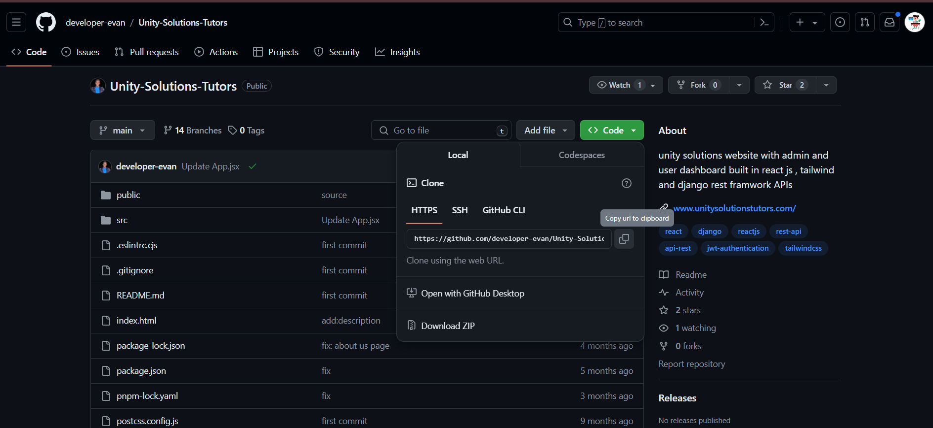

Cloning the repo

Open the command prompt and use the command

git clone https://github.com/developer-evan/Unity-Solutions-Tutors.git

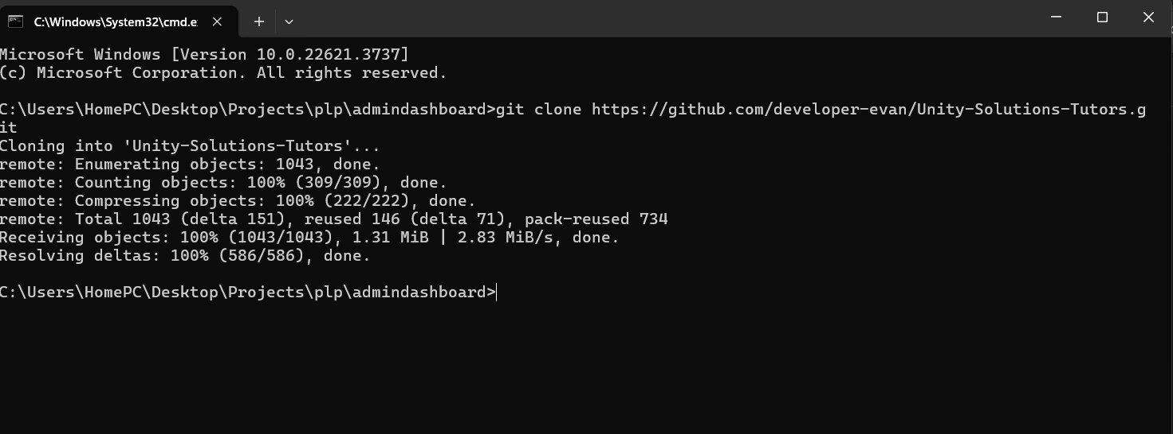

The repository’s structure and files

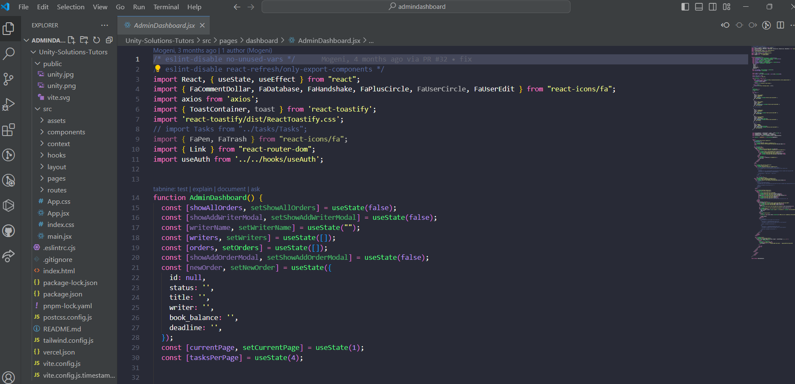

Forking

Creating a fork

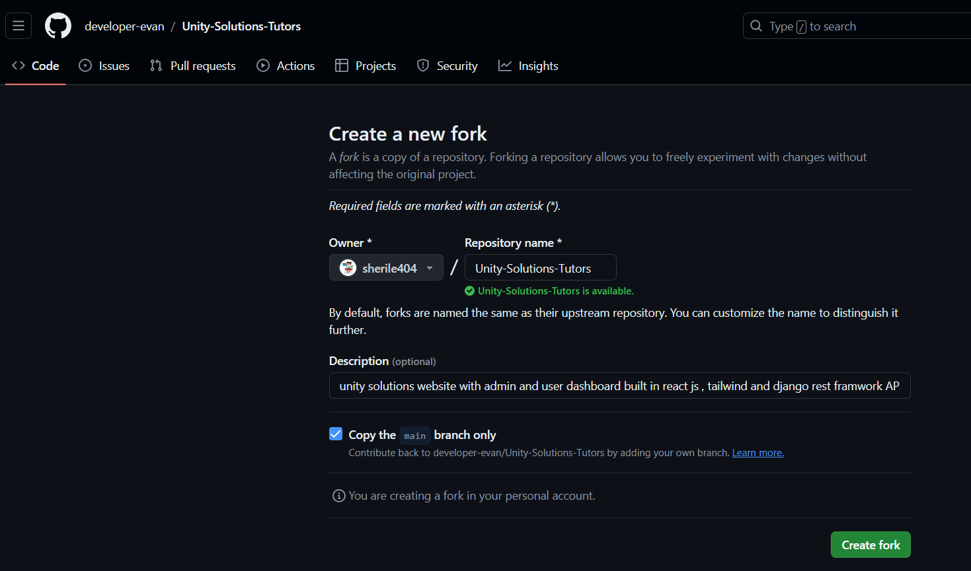

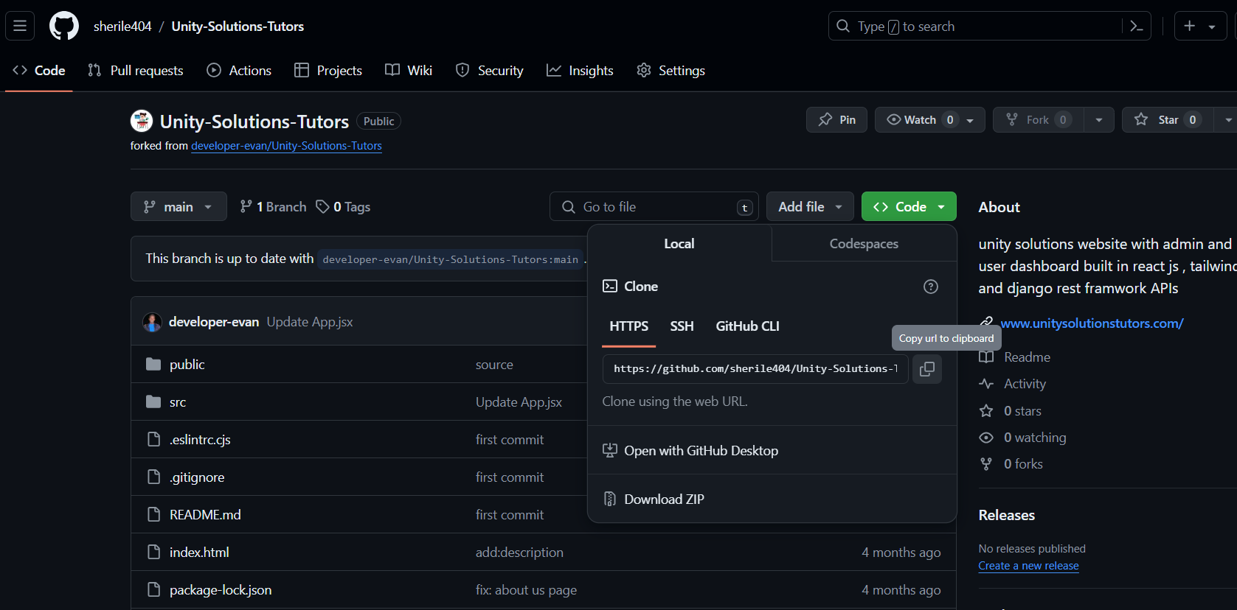

Cloning the fork

Open command prompt and type:

git clone https://github.com/sherile404/Unity-Solutions-Tutors.git

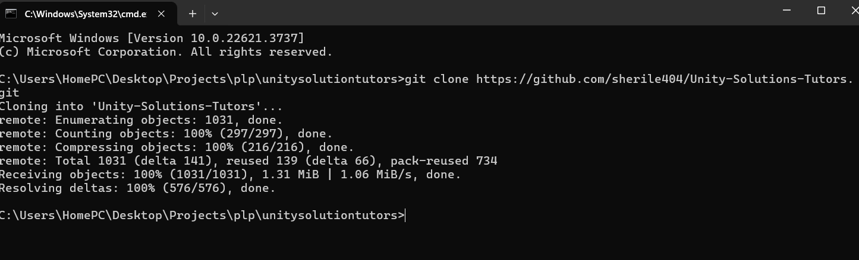

2.Managing branches

Create a new branch using git branch command and switch to the newly created branch using git checkout

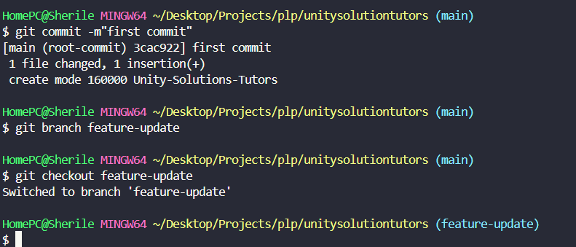

4.Making changes and committing

Adding a new file ‘Reports.jsx’

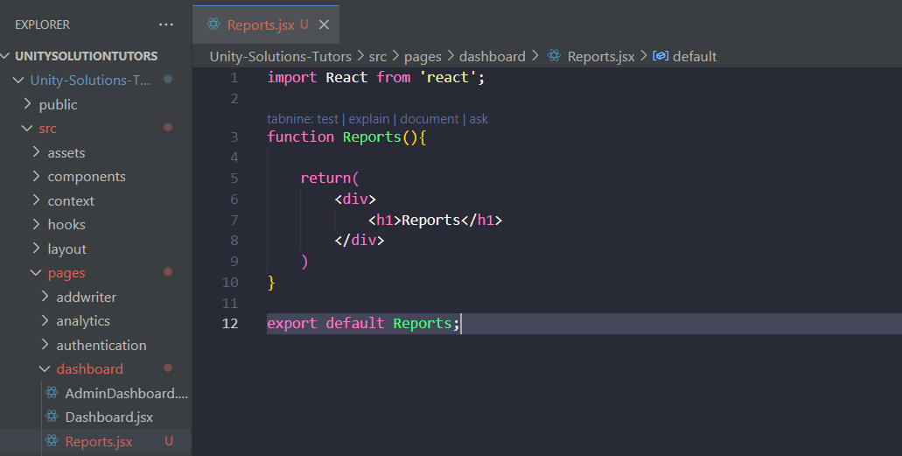

Commit the changes using git commit -m”message”

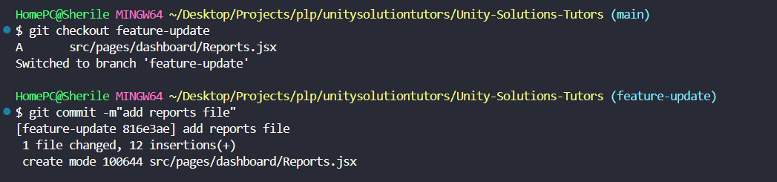

Merge the changes from feature-update into the main branch using git pull origin

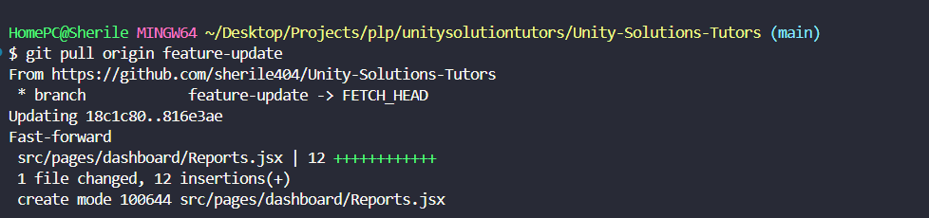

Github pages

HTML file  
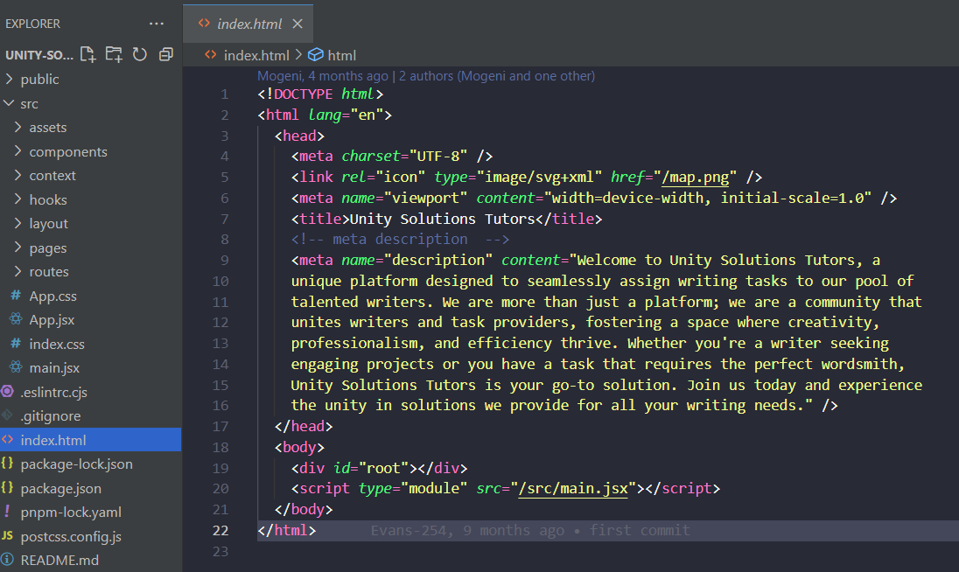

Enabling GitHub pages  
